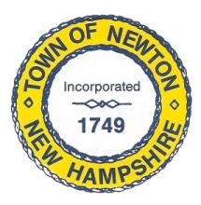
Recreation Commission
2 Town Hall Road, Newton, NH 03858
Tel: 382-4405 ext. 13
www.newton-nh.gov

NEWTON RECREATION COMMISSION
MONDAY, November 20, 2017
TIME: 7:00PM
LOCATION: Town Hall (rear)

MEETING AGENDA

- Call to Order

- Pledge of Allegiance

- Approval of Minutes – November 6, 2017

- Scheduled Business

- Senior Holiday Luncheon (updates – number of seats available)

- Recreation Commission budget

- Any new member news?

- Winter Activities
- Movie Day – Christine Kuzmitski
- Ice Skating – Vice Chairman Burrill
- Discounted Ski Tickets – Chairman St. Cyr
- Snow Tubing – Chairman St. Cyr

- Announcements

- Other Business, Correspondence and Appointments

- Adjourn

Posted on 11/17/2017: Newton Town Hall and Official Town Website @ www.newton-nh.gov

