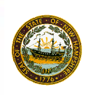
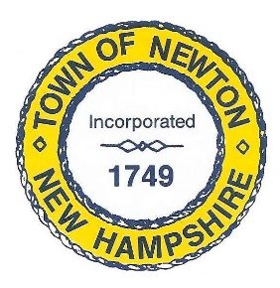
TOWN OF NEWTON, NH
Recreation Commission

2 Town Hall Road
Newton, NH 03858

Date: August 16, 2021

Call to Order - 7:00 pm.
In attendance – Chairman Rick Faulconer, Selectman Matthew Burrill, Vice Chairman Christine Kuzmitski, William Harding, Sue Mears, and Patricia Masterson (recording minutes).
Approval of the Minutes
Mr. Harding made a Motion to approve the Minutes of August 2, 2021. Selectman Burrill seconded the Motion, which passed unanimously.
Olde Home Day
The date for Olde Home Day is September 18, 2021.
Chairman Faulconer made a Motion to pay Stone Getty Graphics $400 for designing and printing 500 programs for Olde Home Day. Mr. Harding seconded the Motion, which passed unanimously.
Selectman Burrill made a Motion to pay the $800 invoice from New England Mobile Audio to provide audio support for the bands during Olde Home Day. Chairman Faulconer seconded the Motion, which passed unanimously.
Selectman Burrill is in contact with Ground Zero to ask for raffle donations. Ms. Masterson is in touch with Empower Martial Arts.
Activities will include music, a car show, food vendors, a raffle, and WooSox Smiley Ball, and games. Selectman Burrill is contacting five bands. We will need a big-ticket item for the raffle. Selectman Burrill suggested a solo stove smokeless firepit or a Yeti cooler. Profits will go to 68 Hours of Hunger and the Newton Food Pantry. We need Volunteers throughout the day.
Chairman Faulconer has been in contact with the Mobile Coronavirus vaccine van and will provide more details. The Newton Fire Association may set up a “Fill the Boot’ display.
Recreation Commission, August 16, 2021, Minutes, Page 2
Senior BBQ
The Recreation Commission will hold a Senior BBQ from 4 to 6pm on September 17 at the Police Complex. In previous years, we sold tickets for $2, which requires people to make a nominal commitment. We will need to coordinate hot dogs and hamburgers, condiments, rolls, paper plates and utensils, napkins, ice cream and drinks. In the past, we have used some of the raffle items collected for Olde Home Day to add fun to the event. Police Officers will help grill and pass out food.
Ms. Masterson will work on the tickets. We will need to decide on a date to sell tickets.
Town Beach
Mary Miller has provided an invoice to be reimbursed for the Lifeguard certification course. As part of the Lifeguard hiring incentive, the Town offered to pay Lifeguards for their certification at the end of their service.
Selectman Burrill made a Motion to reimburse Mary Miller $485 for Lifeguard certification. Chairman Faulconer seconded the Motion, which passed unanimously.
Upcoming Events
Tentative dates for October: October 9 Yard Sale and October 23 Trunk or Treat (October 24 rain date).
Adjournment
Chairman Faulconer made a Motion to adjourn the Meeting at 8:00 p.m. Vice Chair Kuzmitski seconded the Motion, which passed unanimously.
Next Meeting
August 30, 2021, at 7pm will be the next meeting of the Recreation Commission. We will also have a Meeting on September 13.
Respectfully Submitted,

Patricia Masterson, Secretary, Recreation Commission

Posted on 8/31/2021 Newton Town Hall and Official Town website www.newton-nh.gov.

