GALE LIBRARY
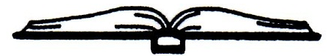
Established 1892
16 South Main Street
Newton New Hampshire 03858
(603) 382-4691

DATE: Friday, October 18, 2019
LOCATION: Gale Library, 16 S Main Street
MEETING MINUTES
- Call to Order 9:00 a.m.
- In Attendance: Lynne Camp, Chairperson; Kathy Meserve, Treasurer; Anne Banks, secretary; Terry Caswell, Director.
- Lynne moved that we enter non-public session to discuss compensation, RSA91-A:3, II(a). Kathy seconded the motion, which passed unanimously.
- Entered Non-Public Session at 9:05.
- Returned to public session at 9:54.
- Motion made by Anne to seal the minutes of the non-public meeting, because not doing so would adversely affect the reputation of a person other than a member of this board. Motion was seconded by Kathy. Motion passed unanimously.
- Public session adjourned at 9:57 a.m.

Respectfully Submitted,

Anne D. Banks, Secretary

