GALE LIBRARY
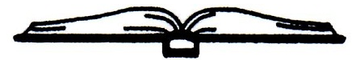
Established 1892
16 South Main Street
Newton New Hampshire 03858
(603) 382-4691

DATE: Monday, December 14, 2020
Conference Call
EMERGENCY MEETING MINUTES
- Call to Order: 12:07 PM
- In attendance via conference call: Lynne Camp, Chairperson; Kathy Meserve, Treasurer; Terry Caswell, Director
- Lynne motioned to approve the carry over of any remaining unused PTO hours for Theresa Caswell to the year 2021. Kathy seconded the motion. The motion passed unanimously; no nay votes were cast.
- Kathy motioned that staff who are in quarantine for possible exposure to Covid-19 be paid for their regular hours according to the Families First Corona Virus Response Act (FFCRA). Lynne seconded the motion. The motion passed unanimously; no nay votes were cast.

The meeting adjourned at 12:30 PM

Respectfully submitted,

Lynne O. Camp, Chairperson/Acting Secretary

