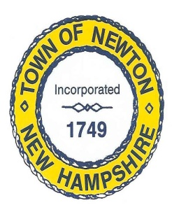

NEWTON CONSERVATION COMMISSION

DATE: Thursday, July 1, 2021 @6:30pm

Location: 2 Town Hall Rd (large hall)

Meeting Minutes

Call to Order at 6:37pm via Roll Call Vote: Chairperson Alicia Geilen, Vice Chair Nancy Slombo, Sandy Estabrook, Trisha McCarthy, Selectman Liaison Kate Michaels. Minutes transcribed by Trisha McCarthy.

Pledge of Allegiance

Correspondence:

- NHDES: Administratively Complete Expedited Application # 2021-01316. Subject property 17 Wenmarks Rd., Tax map 2, lot 2 (application is administratively complete, this is not a permit to begin work)
- Division of Forest and Lands regarding a Timber Harvest on 92 acres of the Sargent Lot #3, in Newton
- Notice of Decision from ZBA: 133 North Main St., Newton allowing for a road centerline setback reduction of 22 feet on the northerly side.
- Kiosk is complete at the Rte 108 side of Peanut Trail. Request letter of thanks and appreciation be sent to the Girl Scouts.
- Discussed purchase of camara’s for conservation land. McCarthy to search prices for discussion at next meeting
- Discussed fixing road at Peanut Trail Entrance (Rte 108 side), leading to parking area. Will discuss with road agent. Once this is done, need to put out the “no parking signs” & “do not block gate, emergency vehicle access”.
- Discussed putting a conservation sign off Patriot Drive re: parking & access
- Discussed the CPLA (Country Pond Lake Association) and sending a letter of support for Grant Application.

Discussions:

- Motion by Slombo to accept minutes of 6/3/21 as amended, second by Estabrook and all in favor
- Discussed we are not getting the “intent to cut” in a timely manner. Reach out to state for explanation.

Motion by Geilen to adjourn at 7:54, second by Estabrook, all in favor
Respectfully, Trisha McCarthy

