Newton Police Department
Welcomes Lucca “the comfort pup”
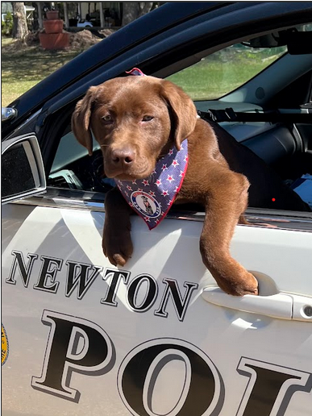
Newton Police Chief Michael Jewett is excited to announce and welcome the latest officer to be joining the ranks of the Newton Police Department. Lucca, a 6-month-old chocolate Labrador puppy, is the department’s first comfort dog.
Police comfort dogs are similar to therapy dogs, serving to comfort people dealing with any kind of stressful or anxious situation, like courtroom testimony, forensic interviews, domestic violence situations, mental health situations, or assistance in the schools.
Officer Brian Oljey, who is Lucca’s handler, is currently assigned as the School Resource Officer at the Memorial School and the Seacoast learning Collaborative School where Lucca will join him daily once she is fully trained by professionals.

Lucca is currently being trained and certified by the local nonprofit Hero Pups, which is based in Exeter, to ensure the dog is ready to report for full time duty upon training completion. Chief Jewett and Officer Oljey have worked closely for approximately a year with Hero Pups, to bring the Newton community and SAU 17, the newest member of the department and the community at large.
Due to the recent pandemic and the often-changing times it is crucial to acknowledge that students today need more attention and emotional support than ever before. It is our responsibility as a community to try to provide any additional support, even that of which may be unconventional. This opportunity we have can be vital in helping students with a new alternative to assist with emotional support during their daily school life.
Lucca’s name, which means “the bringer of light” was inspired by a military dog named Lucca who served in Iraq and Afghanistan and completed over 400 missions and protected countless soldiers’ lives during her years in service. She ultimately lost her leg in an IED explosion, which ended her military career. Lucca was chosen by a poll of students and staff.
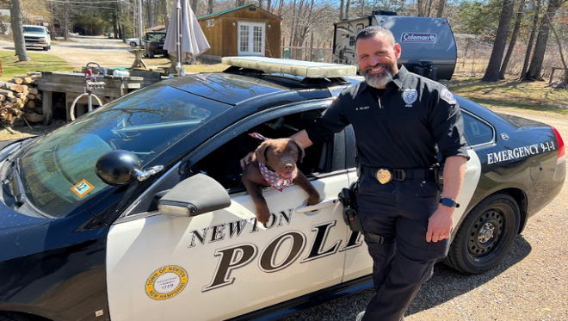
To provide this opportunity at no expense to the community and taxpayers of Newton, Chief Jewett and Officer Oljey are seeking donations to help offset the costs of the program. Anyone interested in contributing can stop by or mail a check to 8 Merrimac Road, Newton, NH. 03858 and make out a check to Newton Police Association with “comfort dog” noted in the memo.
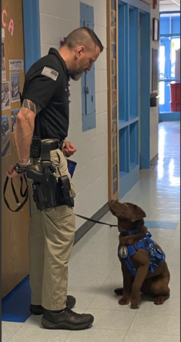
Follow us on Instagram!

