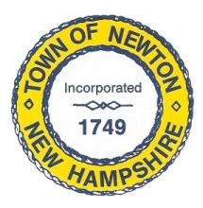
Recreation Commission
2 Town Hall Road, Newton, NH 03858
Tel: 382-4405 ext. 13
www.newton-nh.gov

NEWTON RECREATION COMMISSION
MONDAY, November 6, 2017
TIME: 7:00PM
LOCATION: Town Hall (rear)

MEETING AGENDA

- Call to Order

- Pledge of Allegiance

- Approval of Minutes – October 16, 2017

- Scheduled Business

- Senior Holiday Luncheon

- Town-wide yard sale suggested by a resident

- Trunk or Treat – October 28, 2017, recap

- Recreation Commission budget due in November

- Do we need a new Member after November?

- Snow Tubing

- Announcements

- Other Business, Correspondence and Appointments

- Adjourn

Posted on 11/02/2017: Newton Town Hall and Official Town Website @ www.newton-nh.gov

