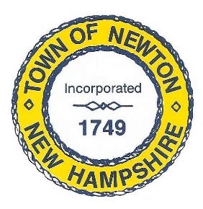
TOWN OF NEWTON, NH
Recreation Commission

2 Town Hall Road
Newton, NH 03858

Date November 20, 2017

Call to Order - 7:00 pm
In attendance – Chairman Stephen St. Cyr , Vice Chairman Vanessa Burrill, Matthew Burrill (representing Selectmen),Christine Kuzmitski, Patricia Masterson (recording minutes)
Approval of Minutes
Vice Chair Burrill made a Motion to approve the Minutes for November 6, 2017, and Ms. Kuzmitski seconded the Motion.
Business
We will continue to look for a new member for the Commission. Selectman Burrill will create and post an announcement on Facebook, and Ms. Masterson will update the Recreation Commission web page.
Senior Holiday Luncheon
The Senior Holiday Luncheon will be held at noon on December 6, 2017, at Roma Restaurant in Haverhill. Ms. Kuzmitski will sign up interested parties at the Town Hall at 9:00 a.m. on November 27, 2017. There are 90 seats available, which includes one guest – Selectmen Chair Jim Doggett, who will open the luncheon with greetings. Gift bags will be given to each attendee and include chocolate pretzels, hand sanitizer, chapstick and possibly calendars or tissues. $100 was approved in the last meeting for gift bags and ingredients.
Budget
The Recreation Commission budget will be submitted on November 21, 2017. Selectmen may accept the budget as a draft. Chairman St. Cyr suggested hiring two lifeguards for the Town Beach – salary to be determined. Selectman Burrill said the request for lifeguards should be put on a warrant article. The lifeguard would have to be insured by the Red Cross or the YMCA.

Recreation Commission November 20, 2017, Minutes, page 2

Adjournment
Vice Chair Burrill made a Motion to adjourn the meeting at 8:40 p.m. Chairman St. Cyr seconded the motion. The Motion was unanimously approved.
THE NEXT MEETING WILL BE HELD ON November 20, 2017, at 7:00 p.m. in the REAR of the TOWN HALL.
Respectfully Submitted,

Patricia Masterson
Recreation Commission Secretary

