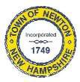
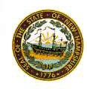
Newton Board of Appeals
2 Town Hall Road
Newton, NH 03858

August 7, 2019

The Newton Board of Appeals will be holding a public meeting on Monday, August 12, 2019 at 7:30 PM at the Town Hall, 2 Town Hall Road.

- Call to order
- Roll Call
- Acceptance of Minutes of the meeting of July 8, 2019
- Old Business
- Adjournment

Next Meeting: September 9, 2019

Posted on 08/07/2019: Newton Town Hall, Newton & Newton Jct. Post Offices, Official Town Website @ www.newton-nh.gov

