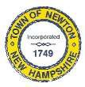
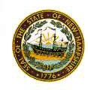
Newton Board of Appeals
2 Town Hall Road
Newton, NH 03858

September 5, 2019

The Newton Board of Appeals will be holding a public meeting on Monday, September 9, 2019 at 7:30 PM at the Town Hall, 2 Town Hall Road.

- Call to order
- Roll Call
- Acceptance of Minutes of the meeting of August 12, 2019
- New Business
Anthony Murphy Public Hearing (1 Merrimac Road: Tax Map#12, Block #4, Lot#5)
- Old Business
Mr. Ferrara regarding Shelterlogic Tent
- Adjournment

Next Meeting: October 15, 2019

Posted on 09/05/2019: Newton Town Hall, Newton & Newton Jct. Post Offices, Official Town Website @ www.newton-nh.gov

