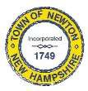
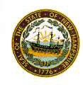
Newton Board of Appeals
2 Town Hall Road
Newton, NH 03858

January 13, 2020

The Newton Board of Appeals will hold a meeting on Monday, January 13, 2020 at 7:30 PM at the Town Hall.

- Call to order
- Roll Call
- Pledge of Allegiance
- Acceptance of Minutes of the meeting of December 9, 2019
- New Business
  - Request for Re-Hearing 125 NH Development Corporation
  - Posting for Secretary position
- Old Business
- Adjournment

Next Meeting: February 10, 2020

Posted on 1/06/2020: Newton Town Hall,Official Town Website @ www.newton-nh.gov

