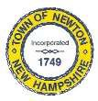
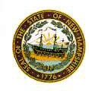
Newton Board of Appeals
2 Town Hall Road
Newton, NH 03858

December 9, 2019

The Newton Board of Appeals will hold a meeting on Monday, December 9, 2019 at 7:30 PM at the Town Hall.

- Call to order
- Roll Call
- Acceptance of Minutes of the meeting of November 12, 2019
- New Business
- Old Business
- Adjournment

Next Meeting: to be determined

Posted on 12/04/2019: Newton Town Hall,Official Town Website @ www.newton-nh.gov

