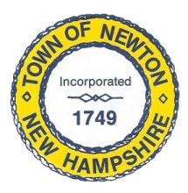
Recreation Commission
2 Town Hall Road, Newton, NH 03858
Tel: 382-4405 ext. 313
www.newton-nh.gov

NEWTON RECREATION COMMISSION
MONDAY, March 2, 2020
TIME: 7:00PM
LOCATION: Town Hall (rear)

MEETING AGENDA

- Call to Order

- Pledge of Allegiance

- Approval of Minutes – February 3, 2018

- Scheduled Business

- Beach sand and cleanup

- Recreation Commission Member Terms
Vanessa Burrill (April 2020)
Christine Kuzmitski (April 2020)
William Harding (April 2022)
Rick Faulkner (April 2022)
Peggy Connors (April 2022)

- Lifeguards Preparation

- Town Meeting – March 10 – Recreation Commission Warrant Articles

- Other Business

- Announcements

- Adjourn

Posted on 02/27/2020: Newton Town Hall and Official Town Website @ www.newton-nh.gov

