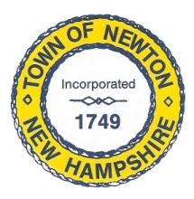
Recreation Commission
2 Town Hall Road, Newton, NH 03858
Tel: 382-4405 ext. 313
www.newton-nh.gov

NEWTON RECREATION COMMISSION
MONDAY, October 4, 2021
TIME: 7:00PM
Town Hall

MEETING AGENDA
The Commission encourages residents to submit written comments or testimony via email or postal mail to be read at the meeting if they are unable to attend the meeting.
Email contact: recreation@newtonnh.net

- Call to Order

- Approval of Minutes September 27, 2021

- Scheduled Business

- Senior BBQ Recap
- Olde Home Day Thank You Letters
- Yard Sale responsibilities
- Trunk or Treat responsibilities

- Other Business
  - Next Meeting – October 18, 2021

- Adjourn

Posted on 9/30/2021: Newton Town Hall and Official Town Website at www.newton-nh.gov

