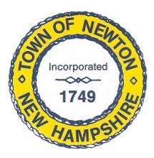
Recreation Commission
2 Town Hall Road, Newton, NH 03858
Tel: 382-4405 ext. 313
www.newton-nh.gov

NEWTON RECREATION COMMISSION
MONDAY, October 18, 2021
TIME: 7:00PM
Town Hall

MEETING AGENDA
The Commission encourages residents to submit written comments or testimony via email or postal mail to be read at the meeting if they are unable to attend the meeting.
Email contact: recreation@newtonnh.net

- Call to Order

- Approval of Minutes October 4, 2021

- Scheduled Business

- Trunk or Treat
- Veterans Day
- Yard Sale
- Resident inquiry about Kingston
- Motions for Grand Central payments
- Rowboat?

- Other Business
  - Next Meeting – November 1, 2021

- Adjourn

Posted on 10/14/2021: Newton Town Hall and Official Town Website at www.newton-nh.gov

