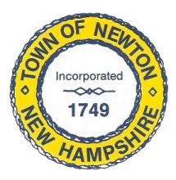
Recreation Commission
2 Town Hall Road, Newton, NH 03858
Tel: 382-4405 ext. 313
www.newton-nh.gov

NEWTON RECREATION COMMISSION
MONDAY, November 18, 2019
TIME: 7:00PM
LOCATION: Town Hall (rear)

MEETING AGENDA

- Call to Order

- Pledge of Allegiance

- Approval of Minutes – October 21, 2019

- Scheduled Business

- Volunteer

- Jingle Run/Winter Events

- Senior Luncheon

- Final Budget 2019

- Packer Meadows Recap

- Next Year’s Schedule of Events

- Other Business

- Adjourn

Posted on 11/14/2019: Newton Town Hall and Official Town Website at www.newton-nh.gov

