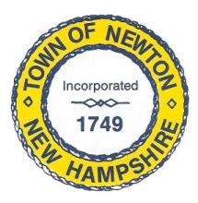
Recreation Commission
2 Town Hall Road, Newton, NH 03858
Tel: 382-4405 ext. 313
www.newton-nh.gov

NEWTON RECREATION COMMISSION
MONDAY, December 9, 2019
TIME: 7:00PM
LOCATION: Town Hall (rear)

MEETING AGENDA

- Call to Order

- Pledge of Allegiance

- Approval of Minutes – November 18, 2019

- Scheduled Business

- Senior Luncheon and related events – all outstanding bills due by 12/12/19

- Encumbered budget items due by 12/12/19 (sand, Country Pond Lake Association)

- Annual Report Write-up

- Winter Events

- 2020 Meeting Schedule

- 2020 Events Schedule

- Other Business

- Adjourn

Posted on 12/04/2019: Newton Town Hall and Official Town Website at www.newton-nh.gov

