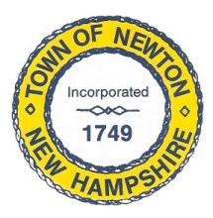
Recreation Commission
2 Town Hall Road, Newton, NH 038
Tel: 382-4405 ext. 313
www.newton-nh.gov

NEWTON RECREATION COMMISSION
MONDAY, February 19, 2024
TIME: 6:00PM

MEETING AGENDA
The Commission encourages residents to submit written comments or testimony via email or postal mail to be read at the meeting if they are unable to attend the meeting. The meeting will be at the Town Hall, 2 Town Hall Road, Newton.
Email contact: recreation@newtonnh.net

- Call to Order

- Approval of Minutes February 5, 2024

- Scheduled Business

- Olde Home Day
  - Entertainment
  - Food
  - Rentals

- Boat Motor for Town Beach

- Plans for A frame signs

- Other Business
  - February 22 – Candidates Night

- Adjourn

- The Next Meeting of the Recreation Commission is March 4, 2024.

Posted on 2/14/2024: Newton Town Hall and Official Town Website at www.newton-nh.gov

