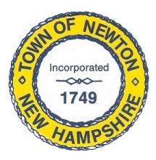
Recreation Commission
2 Town Hall Road, Newton, NH 03858
Tel: 382-4405 ext. 313
www.newton-nh.gov

NEWTON RECREATION COMMISSION
MONDAY, May 21, 2018
TIME: 7:00PM
LOCATION: Town Hall (rear)

MEETING AGENDA

- Call to Order

- Pledge of Allegiance

- Approval of Minutes – May 7, 2018

- Old Business

- Memorial Day Parade
- Town-wide yard sale
- Wetlands permit for beach sand
- Lifeguards

- New Business

B. Olde Home Day – September 15
C. Recreation Bylaws
D. Recreation Commission Inventory
F. 2018 dates for events
G. Chair of Recreation Commission

- Other Business

- Adjourn

Posted on 5/17/2018: Newton Town Hall and Official Town Website @ www.newton-nh.gov

