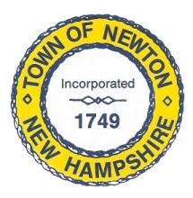
Recreation Commission
2 Town Hall Road, Newton, NH 03858
Tel: 382-4405 ext. 313
www.newton-nh.gov

NEWTON RECREATION COMMISSION
MONDAY, June 18, 2018
TIME: 7:00PM
LOCATION: Town Hall (rear)

MEETING AGENDA

- Call to Order

- Pledge of Allegiance

- Approval of Minutes – May 21, 2018

- Old Business

- Memorial Day Parade
- Town-wide yard sale registration form
- Wetlands permit for beach sand
- Lifeguards

- New Business

A. Olde Home Day – September 15
B. 2018 dates for events for posting
C. Beach fence
D. Bylaws and new requisition process

- Other Business

- Adjourn

Posted on 6/14/2018: Newton Town Hall and Official Town Website @ www.newton-nh.gov

