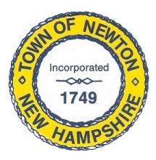
Recreation Commission
2 Town Hall Road, Newton, NH 03858
Tel: 382-4405 ext. 313
www.newton-nh.gov

NEWTON RECREATION COMMISSION
MONDAY, August 30, 2021
TIME: 7:00PM
Town Hall

MEETING AGENDA
The Commission encourages residents to submit written comments or testimony via email or postal mail to be read at the meeting if they are unable to attend the meeting.
Email contact: recreation@newtonnh.net

- Call to Order

- Approval of Minutes August 16, 2021

- Scheduled Business

- Senior Summer Trip Review

- Olde Home Day

  - Follow-up vendors and raffle lists
  - Need Recreation Commission Members to find entertainment
  - Bands – Matt
  - Cars – Peggy
  - Food – Vanessa – Lions Club, Chubbs, Up Turn – need ice cream or pizza
  - Motions – solo stove - $299 plus shipping
  - Volunteers

- Senior BBQ – September 17 (4-6pm)
  - Tickets
  - Food
  - Tables

- Other Business
  - Kerin Lancaster certification
  - Next Meeting

- Adjourn

Posted on 8/26/2021: Newton Town Hall and Official Town Website at www.newton-nh.gov

