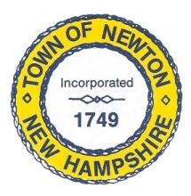
Recreation Commission
2 Town Hall Road, Newton, NH 03858
Tel: 382-4405 ext. 313
www.newton-nh.gov

NEWTON RECREATION COMMISSION
MONDAY, September 13, 2021
TIME: 7:00PM
Town Hall

MEETING AGENDA
The Commission encourages residents to submit written comments or testimony via email or postal mail to be read at the meeting if they are unable to attend the meeting.
Email contact: recreation@newtonnh.net

- Call to Order

- Approval of Minutes August 30, 2021

- Scheduled Business

- Senior Summer BBQ
  - Ticket numbers/food/Grand Rental/purchase gift cards

- Olde Home Day

  - Follow-up vendors and raffle lists (attached)
  - Entertainment/Games
  - Bands – Matt
  - Cars – Peggy
  - Volunteers and Schedule (attached)
  - Program

- Other Business
  - Yard Sale – October 9?
  - Next Meeting – September 27, 2021

- Adjourn

Posted on 9/9/2021: Newton Town Hall and Official Town Website at www.newton-nh.gov

