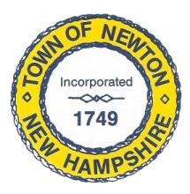
Recreation Commission
2 Town Hall Road, Newton, NH 03858
Tel: 382-4405 ext. 313
www.newton-nh.gov

NEWTON RECREATION COMMISSION
MONDAY, September 27, 2021
TIME: 7:00PM
Town Hall

MEETING AGENDA
The Commission encourages residents to submit written comments or testimony via email or postal mail to be read at the meeting if they are unable to attend the meeting.
Email contact: recreation@newtonnh.net

- Call to Order

- Approval of Minutes September 27, 2021

- Scheduled Business

- Yard Sale – October 16 – signs, map
- Trunk or Treat – October 23 – tasks
- 2022 Budget
- Olde Home Day Recap
- Senior BBQ Recap
- Buildings Inspection Complete
- Town Beach Ropes

- Other Business
  - Next Meeting – October 4, 2021

- Adjourn

Posted on 9/23/2021: Newton Town Hall and Official Town Website at www.newton-nh.gov

