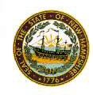
Newton Board of Appeals
2 Town Hall Road
Newton, NH 03858

October 19, 2020

The Newton Board of Appeals will hold a meeting on Monday, October 19, 2020 at 7:30 PM at the Town Hall.

- Call to order
- Roll Call
- Acceptance of Minutes of the meeting of September 21, 2020
- New Business
- Old Business
- Adjournment

Next Meeting: to be determined

Posted on 10/18/2020: Newton Town Hall, Official Town Website @ www.newton-nh.gov

