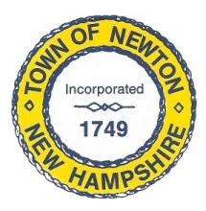
Recreation Commission
2 Town Hall Road, Newton, NH 03858
Tel: 382-4405 ext. 13
www.newton-nh.gov

NEWTON RECREATION COMMISSION
MONDAY, January 8, 2018
TIME: 7:00PM
LOCATION: Town Hall (rear)

MEETING AGENDA

- Call to Order

- Pledge of Allegiance

- Approval of Minutes – December 4, 2017

- Scheduled Business

- Recreation Commission budget/warrant articles

- Country Pond fence and siding update

- Winter Activities
- Movie Day – Christine Kuzmitski
- Ice Skating – Vice Chairman Burrill
- Discounted Ski Tickets – Chairman St. Cyr
- Snow Tubing – Chairman St. Cyr

- Use of credit card

- Olde Home Day thank you letters – vendors sent; no addresses for raffles

- Announcements

- Other Business, Correspondence and Appointments
- 2018 Meeting Schedule – posted on Town bulletin board and website

- Adjourn

Posted on 1/03/2018: Newton Town Hall and Official Town Website @ www.newton-nh.gov

