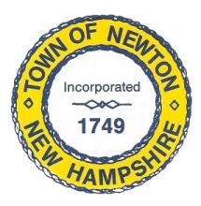
Recreation Commission
2 Town Hall Road, Newton, NH 03858
Tel: 382-4405 ext. 13
www.newton-nh.gov

NEWTON RECREATION COMMISSION
MONDAY, February 5, 2018
TIME: 7:00PM
LOCATION: Town Hall (rear)

MEETING AGENDA

- Call to Order

- Pledge of Allegiance

- Approval of Minutes – January 8, 2018

- Scheduled Business

- Recreation Commission warrant articles

- Beach sand

- Winter Activities
- Movie Day – Christine Kuzmitski
- Ice Skating – Vice Chairman Burrill
- Snow Tubing – Chairman St. Cyr

- Requisitions and credit card - Patricia

- Olde Home Day thank you letters and addresses/supplies – Patricia

- Newton Baptist events

- Announcements

- Adjourn

Posted on 2/1/2018: Newton Town Hall and Official Town Website @ www.newton-nh.gov

