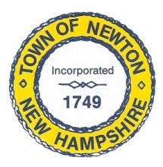
Recreation Commission
2 Town Hall Road, Newton, NH 03858
Tel: 382-4405 ext. 13
www.newton-nh.gov

NEWTON RECREATION COMMISSION
MONDAY, March 5, 2018
TIME: 7:00PM
LOCATION: Town Hall (rear)

MEETING AGENDA

- Call to Order

- Pledge of Allegiance

- Approval of Minutes – February 5, 2018

- Scheduled Business

- Beach cleanup

- Winter Activities
- Movie Day – Christine Kuzmitski
- Ice Skating – Vice Chairman Burrill
- Snow Tubing – Chairman St. Cyr

- Child care funding February and April 2019

- Wetlands permit for beach sand

- Newton Baptist events followup

- Announcements

- Adjourn

Posted on 3/1/2018: Newton Town Hall and Official Town Website @ www.newton-nh.gov

