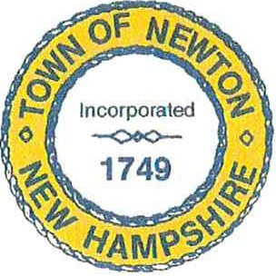
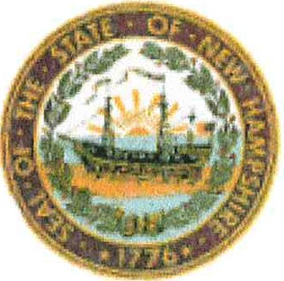
Zoning Board of Adjustment
2 Town Hall Road Newton, NH 03858

(603) 382-4405 X327

NOTICE OF DECISION

The application submitted by Jeffery Card of Newton, NH, requesting an Equitable Waiver in relief of Ordinance XI Non-Conforming Lots, Structures, And Uses, Section 3, Expansion of Non-Conforming Structures for their property at 1A Wilder's Grove Road was heard on March 1st, 2023. The Newton ZBA granted the relief sought, having found that the applicant has satisfied all of the requirements of an Equitable Waiver, to wit the error in measurement for the foundation was not malicious nor intentional and allowing for the rebuilding of the dwelling in accordance with the supplied Plot Plan (V. W. Dingman Consulting, revision dated 91-19-2023). By a UNANIMOUS vote. The property is referenced as Tax Map 2, Block 3, Lot 35-1

______________________________

John Kozec, Chair
Newton Zoning Board of Adjustment
March 3rd, 2023

cc:
Jeffery and Barbara Card

Building Department Health Department Assessor's Office
Fire Department Fire Department Police Department Conservation Commission Board of Selectmen Planning Board ZBA Files

